Chris Gorham

Bellevue University

WEB 335 – Introduction to NoSQL

Professor Krasso

Week 4

4/3/2023

Assignment 4.3 - MongoDB Shell

Screenshots:

2. Write a query to display all the documents in the user’s collection. Take a screenshot of the output and save it as an image.

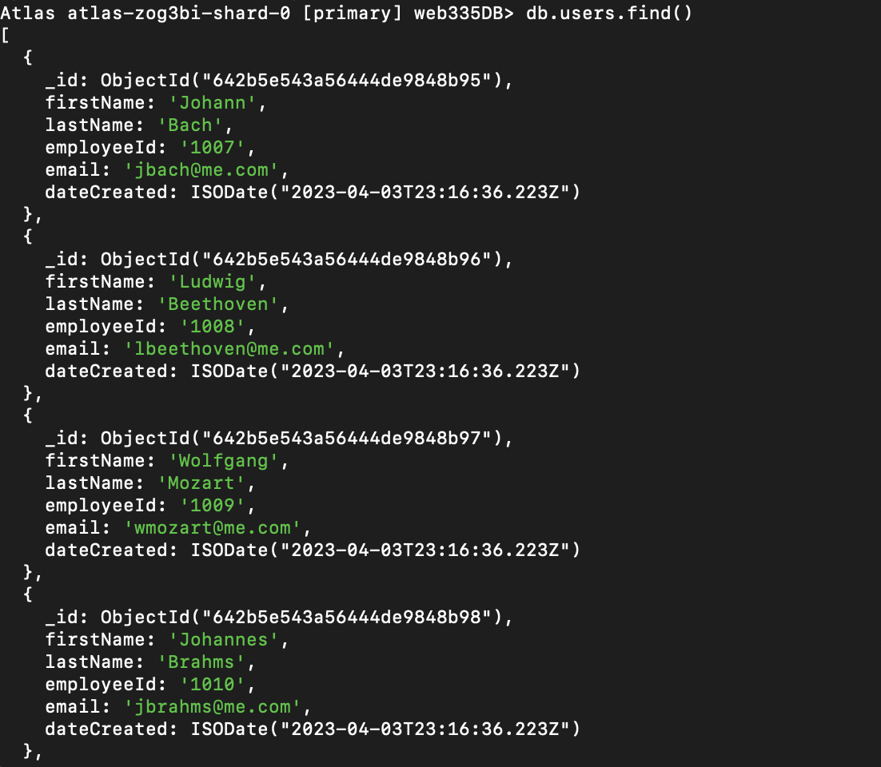

3. Write a query to find the user with an email address of [jbach@me.com](mailto:jbach@me.com). Take a screenshot of the output and save it as an image.

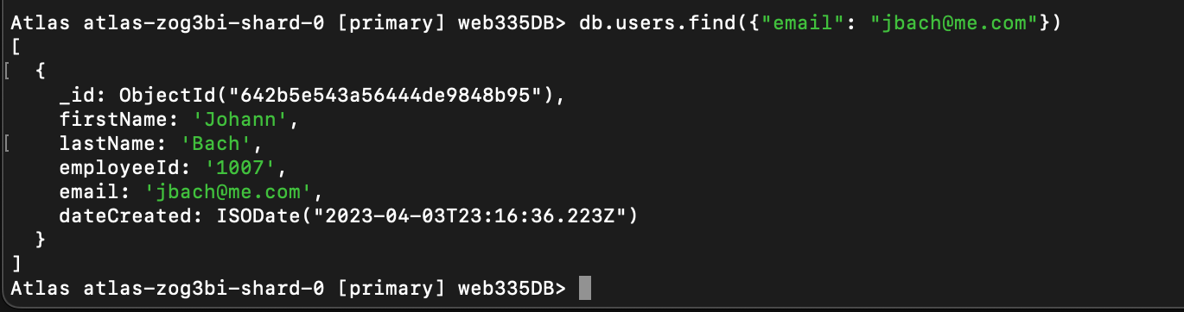

4. Write a query to find a user with the last name of Mozart. Take a screenshot of the output and save it as an image.

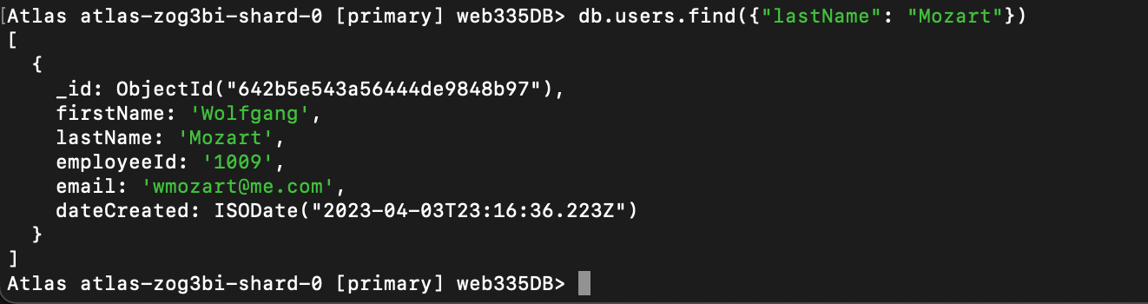

5. Write a query to find a user with the first name of Richard. Take a screenshot of the output and save it as an image.

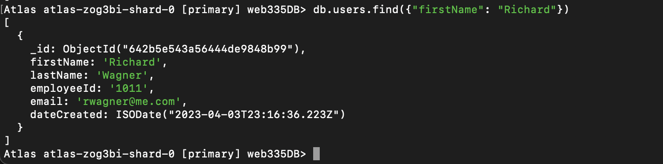

6. Write a query to find a user with an employeeId of 1010. Take a screenshot of the output and save it as an image.

